**Assignment**

SE101-Introduction to Software Engineering

Due Date: 05-Dec-2022

Submitted by

**Muhammad Mustafa Khan**

4321-FBAS/BSSE/F21-A

Submitted to

**Sir Shakir Rasheed Khan Khattak**



Department of Computer Science and Software Engineering

INTERNATIONAL ISLAMIC UNIVERSITY ISLAMABAD

Semester Fall 2022

**Class Diagram:**

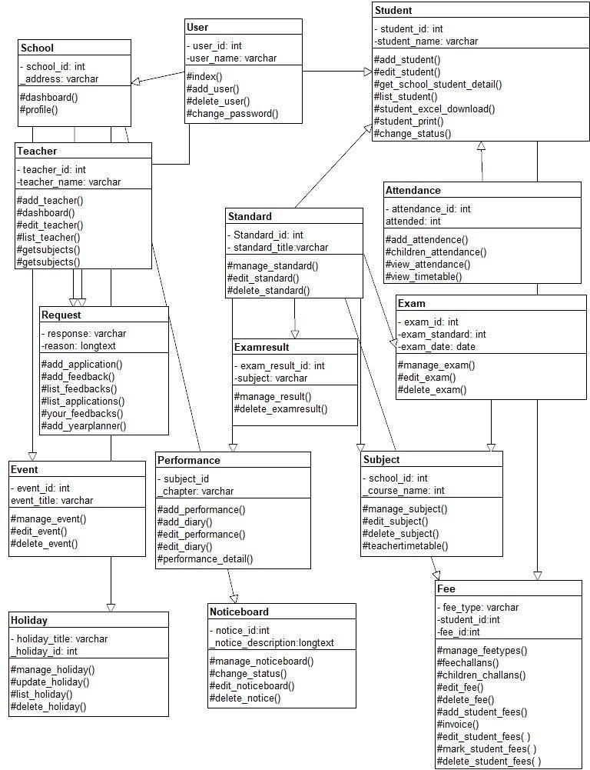

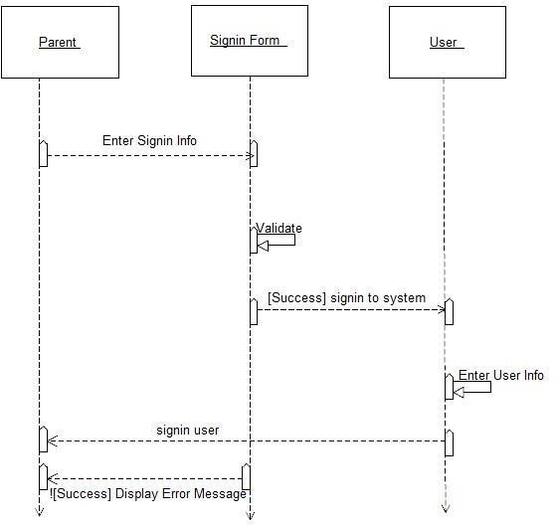**Sequence Diagram:**

